[EduBlock]
[A Blockchain-based system for secure degree issuance and verification.]

Research Report I



Supervisor

[Mr. Kareem Ullah]

Submitted by

[Muhammad Zulqarnain Awan]
[2022-ag-7995]

BS [Software Engineering]
Department of Computer Science
University of Agriculture, Faisalabad

Table of Contents

1. INTRODUCTION 1
1.1 Background 1
1.2 Description 1
1.3 Scope 1
1.4 Objectives 2
2. REQUIREMENTS 2
2.1 Functional Requirements 2
2.2 Non- Functional Requirements 3
2.3 Hardware Requirements 4
2.4 Software Requirements 4
3. METHODOLOGY 4
3.1 Agile Development Methodology 4
3.2 Use Case Diagram 5
3.2.1 Actors 5
3.2.2 Use Cases 5
3.3 Tools & Technologies 6
4. Timeline 6
4.1 Gantt Chart 6
5. References 7

List of Figures

Figure 1: Agile Methodology, Scrum Process 4
Figure 2: Use Case diagram 5
Figure 3:Timeline (Gantt Chart) 6

1. INTRODUCTION

1.1 Background
In the current educational landscape, the issuance and verification of academic degrees are predominantly paper-based processes. These traditional methods are fraught with inefficiencies, including significant time delays in verification and a high susceptibility to fraud. Fake degrees and credential fraud have become a global concern, undermining the credibility of educational institutions and employers alike. The manual verification process often involves tedious correspondence between employers and universities, which can take weeks or even months. To address these critical issues, there is a pressing need to transition from physical, alterable records to immutable, digital assets. This project initiates the development of a secure system that leverages modern cryptographic technology to ensure the integrity of academic credentials.

1.2 Description
EduBlock is a web-based application designed to revolutionize the management of academic credentials. It utilizes blockchain technology to issue, store, and verify digital degrees. The system creates a decentralized trust network where the university acts as the issuer, the student as the recipient, and third parties (such as employers) as verifiers.
Technically, the front end is built using React, providing a responsive and interactive user interface for all stakeholders. The back end is powered by Python, which handles API requests and interacts with the blockchain. The core security feature involves smart contracts written in Solidity, which govern the issuance and verification logic. When a degree is issued, its cryptographic hash is stored on the blockchain, making it tamper-proof. Metadata and degree files are stored using IPFS (InterPlanetary File System) to ensure decentralized storage efficiency. This system ensures that once a degree is issued, it cannot be faked or modified, and its authenticity can be verified instantly via a QR code or unique Token ID.

1.3 Scope
The scope of EduBlock encompasses the digitization of the degree issuance and verification lifecycle.
- For Institutes: The system provides a web portal to upload student data, generate digital degrees, and record their hashes on the blockchain.
- For Students: It offers a digital wallet interface where students can view their credentials and share them securely via a link or QR code.
- For Verifiers (Employers/Third Parties): The system includes a verification mechanism that scans QR codes or accepts Token IDs to instantly confirm the validity of a degree against the blockchain ledger.
- Exclusions: The system focuses on the final issuance of degrees and does not cover the entire student management system (e.g., attendance, course registration) prior to graduation.

1.4 Objectives
The primary goal of this project is to eliminate credential fraud and streamline verification. The specific objectives are:
- Build a blockchain-based verification system: To develop a decentralized application (DApp) that records degree data immutably.
- Prevent fake or duplicate degrees: To ensure that only authorized university personnel can mint degree tokens, making forgery mathematically impossible.
- Enable instant QR-based verification: To allow third-party verifiers to check a degree's authenticity in real-time without contacting the university.
- Store degree hashes on blockchain: To utilize the Ethereum network (or similar EVM) to store the cryptographic proof of every issued degree.

2. REQUIREMENTS

2.1 Functional Requirements
Functional requirements precisely specify what the EduBlock system should do to achieve its goals. For this blockchain-based degree verification system, these requirements define the critical interactions between the React frontend, the Python backend, and the Ethereum blockchain. They detail how the system handles the unique challenge of minting digital assets (degrees) and ensuring they are retrievable and verifiable by third parties without compromising data integrity.

FR01: Admin/institute login
FR01-01 | System shall get Username and Password from the Institute Admin.
FR01-02 | System should authenticate credentials against the PostgreSQL database.
FR01-03 | System shall grant access to the dashboard if credentials are valid.
FR01-04 | If information is invalid, the system shall display an error message.

FR02: Issue Degree (Minting)
FR02-01 | System shall allow Admin to input student details (Name, Reg No, CGPA).
FR02-02 | System shall generate a cryptographic hash of the degree data.
FR02-03 | System shall upload degree metadata/image to IPFS (InterPlanetary File System).
FR02-04 | System shall execute a Smart Contract transaction to store the hash on the blockchain.

FR03: Verify Degree
FR03-01 | System shall allow a Verifier to input a Token ID or scan a QR code.
FR03-02 | System shall fetch the hash associated with the ID from the blockchain.
FR03-03 | System shall compare the blockchain hash with the provided degree data.
FR03-04 | System shall display "Verified" or "Fake" status based on the comparison.

FR04: Student Wallet/Dashboard
FR04-01 | System shall allow students to view their issued digital degrees.
FR04-02 | System shall display the degree status (Pending, Issued, Revoked).
FR04-03 | System shall allow students to download a PDF copy of the degree.

FR05: Share Credentials
FR05-01 | System shall generate a unique QR code for each issued degree.
FR05-02 | System shall provide a shareable public link for third-party verification.
FR05-03 | System shall allow the student to copy the transaction hash for manual proof.

FR06: Admin User Management
FR06-01 | System shall allow the Super Admin to add new university.
FR06-02 | System shall allow the assignment of specific roles (e.g., Issuer, Viewer).

FR07: Smart Contract Management
FR07-01 | System shall allow the deployment of the smart contract to the blockchain network.
FR07-02 | System shall record the contract address in the system configuration.

FR08: Notifications
FR08-01 | System shall send an email to the student when a degree is successfully minted.
FR08-02 | System shall notify the Admin if a blockchain transaction fails (e.g., out of gas).

2.2 Non- Functional Requirements
Non-functional requirements specify how the system performs its functions, focusing on quality attributes rather than specific behaviors. For EduBlock, these requirements are crucial because they address the trust and security inherent to blockchain technology. They define the system's reliance on the immutability of the distributed ledger, the responsiveness of the web interface across devices, and the security measures required to prevent unauthorized minting of degrees.

NFR01: The system must ensure that only the university owner account can deploy smart contracts and mint degrees.
NFR02: Data stored on the blockchain must be immutable; no user (including Admin) can alter a degree after issuance.
NFR03: The web application should be accessible 99% of the time via standard web browsers.
NFR04: The verification process should require no more than 3 clicks or one scan action.
NFR05: Verification results should be retrieved from the blockchain/node within 5 seconds under normal network conditions.

2.3 Hardware Requirements
Processor: Intel Core i5 or higher (for development and server hosting).
RAM: 8GB or more (required for running local blockchain nodes like Ganache and React servers).
Hard Disk: 50GB free space.
Internet: Stable broadband connection for interaction with the Blockchain testnet (e.g., Sepolia/Goerli).

2.4 Software Requirements
Operating System: Windows 10/11, macOS, or Linux.
Browser: Google Chrome (with Metamask extension installed) or Firefox.
Code Editor: VS Code.
Blockchain Tools: Ganache (for local testing), Metamask (Wallet).

3. METHODOLOGY

3.1 Agile Development Methodology
The development of EduBlock will follow the Agile Methodology. Given the complexity of blockchain integration and the need for iterative testing of smart contracts, Agile is superior to rigid models like Waterfall.
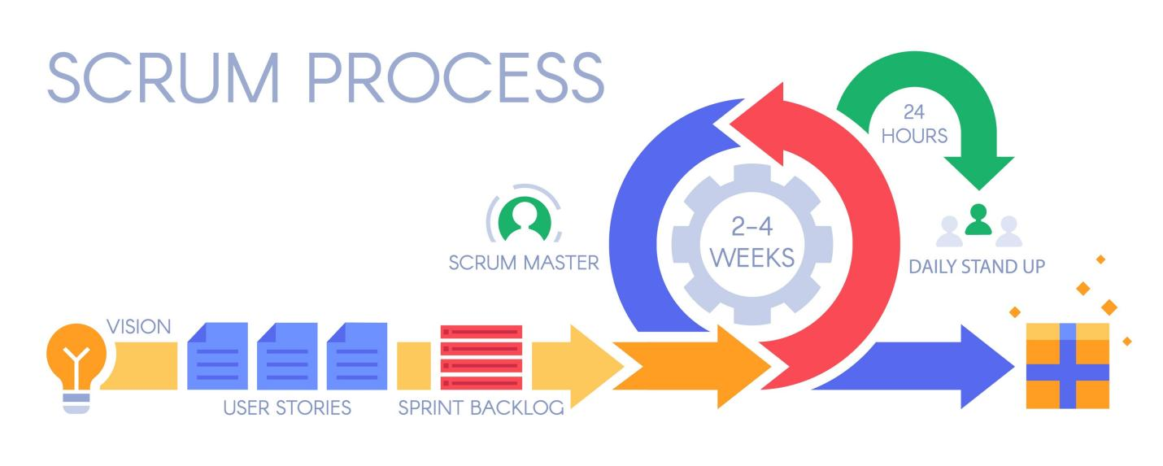
In this approach, the project is divided into small, manageable units called "sprints." Each sprint results in a potentially shippable product increment. For example, the first sprint focuses on the Smart Contract development (backend logic), while subsequent sprints focus on the React frontend and integration. This allows for continuous feedback and testing, which is critical because smart contracts cannot be easily modified once deployed to the mainnet.
Figure 1: Agile Methodology, Scrum Process

3.2 Use Case Diagram
The Use Case Diagram for EduBlock outlines the core interactions between the primary stakeholders (Institute Admin, Students, Verifiers) and the system.

3.2.1 Actors
- Institute Admin (Issuer): The university authority responsible for authenticated access and minting degrees.
- Student (Recipient): The degree holder who views and shares their credentials.
- Verifier (Employer/Third Party): External entities who validate the authenticity of the degree.
- Super Admin: The high-level administrator who manages university accounts.

3.2.2 Use Cases
- Login/Authenticate: Secure access for Admins and Super Admins.
- Issue Degree (Minting): Input student details and record hash on blockchain.
- Verify Degree: Check authenticity via Token ID or QR code.
- View Digital Wallet: Students view their issued degrees.
- Download Degree: Save a PDF copy of the credential.
- Share Credentials: Generate shareable links or QR codes.
- Manage Universities: Super Admin adds new institutes and assigns roles.
- Logout: Securely exit the system.

Figure 2: Use Case diagram

3.3 Tools & Technologies
Front End: React.js (JavaScript library for building user interfaces).
Back End: Python (handling server-side logic and API requests).
Blockchain Interaction: Ethers.js (JavaScript library for frontend wallet connection) + Web3.py (Python library for backend blockchain operations)
Smart Contracts: Solidity (Language for writing smart contracts).
Database: PostgreSQL (For storing non-critical user data like user profiles).
Storage: IPFS (InterPlanetary File System for decentralized storage of degree images/PDFs).
Framework: FastAPI or Flask (Python web framework).

4. Timeline
The timeline of “EduBlock” is represented using gantt chart, which I create in visio.

4.1 Gantt Chart
A Gantt chart is a timeline view that makes it easy to see how a project is tracking. You can visualize project tasks and see how they relate to each other as projects progress over time. Use this tool to simplify your tasks and details with a visual project timeline by transforming task names, start dates, durations, and end dates into cascading horizontal bar charts.
Requirement Gathering: Weeks 1-2
System Analysis & Design (UML): Weeks 3-4
Smart Contract Development (Solidity): Weeks 5-7
Backend Development (Python/Web3.py): Weeks 8-10
Frontend Development (React): Weeks 11-13
Integration (Connecting React to Blockchain): Weeks 14-15
Testing (Unit & Security Audits): Weeks 16-17
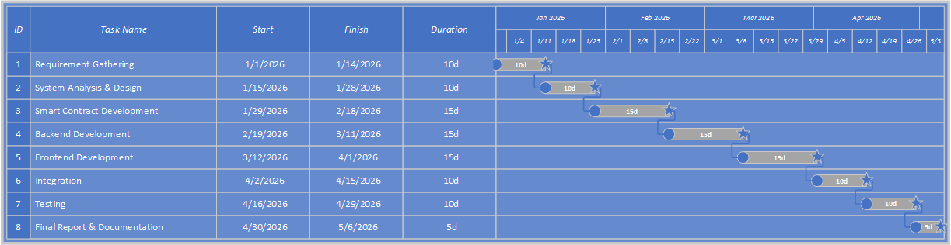
Final Report & Documentation: Weeks 18
Figure 3:Timeline (Gantt Chart)

5. References
Grech, A., & Camilleri, A. F. (2017). Blockchain in Education. JRC Science for Policy Report. European Commission.
Nakamoto, S. (2008). Bitcoin: A Peer-to-Peer Electronic Cash System.
Turkanović, M., Hölbl, M., Košič, K., Heričko, M., & Kamišalić, A. (2018). EduCTX: A blockchain-based higher education credit platform. IEEE Access, 6, 5112-5127.
Cheng, J. C., Lee, N. Y., Chi, C., & Chen, Y. H. (2018). Blockchain and smart contract for digital certificate. In IEEE International Conference on Applied System Innovation (ICASI).
Wood, G. (2014). Ethereum: A secure decentralised generalised transaction ledger. Ethereum project yellow paper, 151(2014), 1-32.

